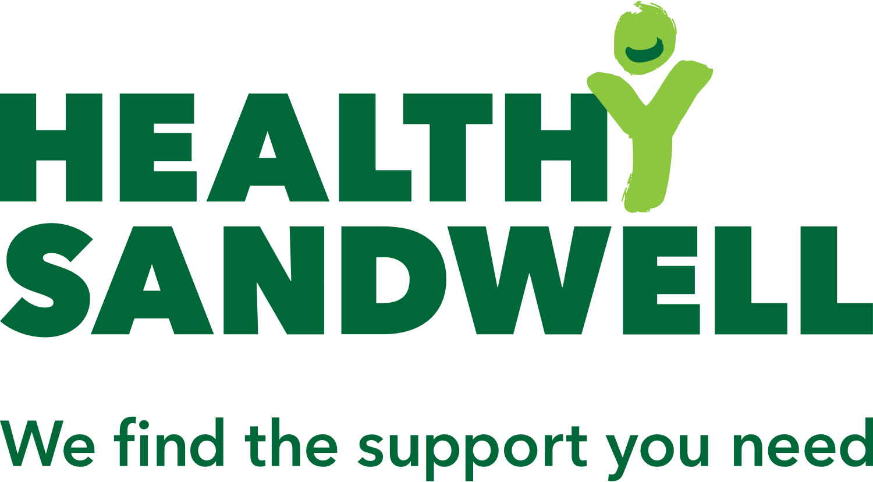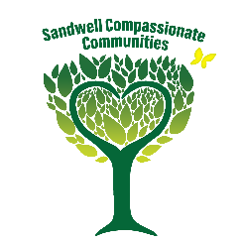

**Sandwell End of Life Care & Compassionate Communities Questionnaire 2024**

*Sandwell Council Public Health want to find out your thoughts and opinions on the six Sandwell Better Endings End-of-Life Care Strategy promises.  Your responses will help us understand what is working well, what we can improve and overall, how we can better meet the needs of our Sandwell community.*

*This survey is aimed at Sandwell residents aged 18+.*

*Your time and insights are much appreciated.  They will provide valuable contribution in shaping the future of End-of-Life Care work and bereavement support in Sandwell.*

1. **How comfortable do you feel talking about end-of-life care/ planning ahead/ death?**

🞏 Very comfortable

🞏 Somewhat comfortable (would prefer someone else opening the conversation)

🞏 Not at all comfortable

**What would make you feel more comfortable to talk about end-of-life care/ planning ahead?**

1. **Are you aware of the available support for end-of-life care/planning ahead?**

🞏 Yes - please detail

………………………………………………………………………………………………………………..…………..………………..…..

🞏 No

1. **Where would be a comfortable place to learn more/ talk about end-of-life care, planning ahead, death?**

**\*Please tick all that apply.**

🞏 local library

🞏 local community organisation

🞏 local faith venue

🞏 other: ………………………………………………………………………………………..………………………………………..

1. **Are you aware of any local organisations that are providing support/care at end of life, bereavement, loss and grief support?**

🞏 Yes - please detail

……………………………………………………………………………………………………………….……….………..………………

🞏 No

1. **What suggestions might you have that could address social, cultural, and spiritual needs at the end of life?**

…………………………………………………………………………………………………………………………………………………

…………………………………………………………………………………………………………………………………………………

1. **Have you been bereaved in the last 10 years?**

🞏 yes

🞏 no

If no, please go to Question 11.

1. **How timely was communication from your health care professional(s) to tell you that your loved one(s) were likely to die?**

🞏 information was shared very clearly at the right time

🞏 information was not clearly explained

🞏 information was not shared early enough and left me confused about what was happening

1. **How would you rate the healthcare professionals’ communications with you during the final period of your loved one’s life?**

🞏 Very good

🞏 Good

🞏 Neither good nor poor

🞏 Poor

🞏 Very poor

1. **Did you access any bereavement support at any point?**

🞏 No

🞏 Yes - local support

🞏 Yes - national helpline

1. **If you did not access any organisations for bereavement support, please explain your reasons.**

🞏 I didn't need any support/I could cope on my own

🞏 I received support from family and friends

🞏 I received support from the local group I attend

    🞏 I wasn't aware of the available support

🞏 Long waiting time

🞏 Lack of support local to me

🞏 Language barrier

     🞏 I didn't consider available support meets my needs - please detail:

………………………………………………………………………………………………………………………………………………

     🞏 Other reasons - please detail:

……………………………………………………………………………………………………………………………………………….

1. **What further comments or suggestions do you have around Sandwell bereavement support?**

…………………………………………………………………………………………………………………………………………………

…………………………………………………………………………………………………………………………………………………

1. **Please list any suggestions you may have around support at the end of life in Sandwell.**

…………………………………………………………………………………………………………………………………………………

…………………………………………………………………………………………………………………………………………………

**How old are you?**

🞏 Under 18 🞏 18 – 24 🞏 25 – 34 🞏 35 – 44 🞏 45 – 54 🞏 55 – 64 🞏 65 & over

**What gender do you identify as?**

🞏 Male 🞏 Female 🞏 Trans-gender 🞏 Non-binary 🞏 Other_________

🞏 Prefer not to say

**What is your marital status?**

🞏 Married or domestic partnership 🞏 Divorced 🞏 Separated 🞏 Single 🞏 Widowed

🞏 Prefer not to say

**Which Sandwell town do you live in?**

🞏 Oldbury 🞏 Tipton 🞏 Rowley Regis 🞏 Smethwick 🞏 Wednesbury 🞏 West Bromwich

**What is your ethnic background? Choose one option that best describes your ethnic group or background.**

**White Asian/ Asian British**

🞏 White English/ Welsh/Scottish/ Northern Irish/ British 🞏 Indian

🞏 White Irish 🞏 Pakistani

🞏 Gipsy or Irish Traveller 🞏 Sikh

🞏 Roma 🞏 Bangladeshi

🞏 Any other White background: 🞏 Chinese

please describe ……………………………… 🞏 Any other Asian background:

please describe…………………………………

**Mixed/Multiple ethnic groups Black/African/Caribbean/ Black British**

🞏 White and Black Caribbean 🞏 African

🞏 White and Black African 🞏 Caribbean

🞏 White and Asian 🞏 Any other Black/ African/ Caribbean

🞏 Any other Mixed/ Multiple ethnic background: Please describe ……………………………….

Please describe ……………………………….

**Other ethnic group**

🞏 Arab

🞏 Any other ethnic group, please describe ……………………………

**🞏 Prefer not to answer**

**What is your highest level of education?**

🞏 No Qualifications

🞏 Other Qualifications; includes foreign qualifications and some professional qualifications

🞏 NVQ 1 Equivalent e.g. fewer than 5 GCSEs at grades A-C, foundation GNVQ, NVQ 1, or equivalent

🞏 NVQ 2 Equivalent e.g. 5 or more GCSEs at grades A-C, intermediate GNVQ, NVQ 2, or equivalent

🞏 NVQ 3 Equivalent e.g. 2 or more A levels, advanced GNVQ, NVQ 3, or equivalent

🞏 NVQ 4 Equivalent and above e.g. HND, Degree and Higher Degree level qualifications or equivalent

­­

**­**

